Task-13

Output

1. Create a Excel Sheet with the following parameters.

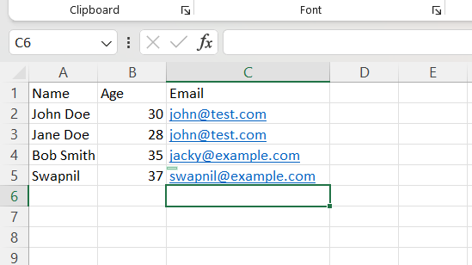

1. Read the data in the excel sheet.

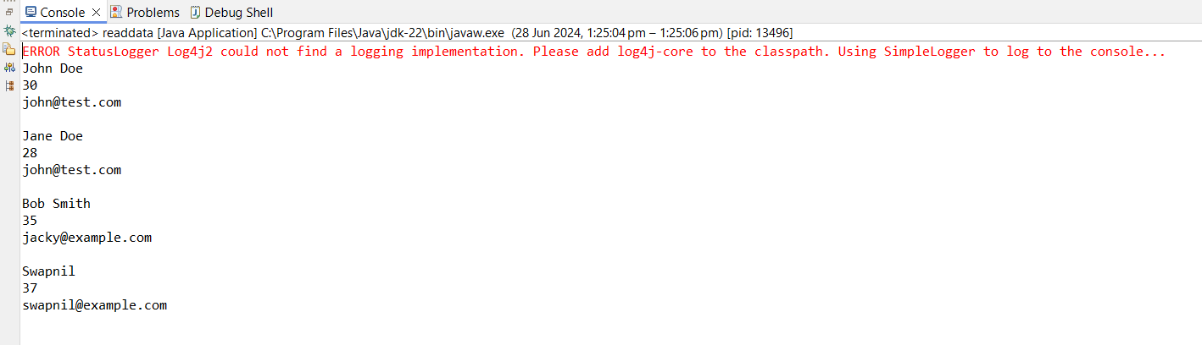

1. Write the data in the excel file.

